**KWAME NKRUMAH UNIVERSITY OF SCIENCE AND TECHNOLOGY**

**CHEMICAL ENGINEERING DEPARTMENT**

**CHE 158: INTRODUCTION TO INFORMATION TECHNOLOGY**

**INSTRUCTOR:** Dr. (Mrs.) Mizpah A. D. Rockson

LECTURE 4: **SPECIALIZED APPLICATION SOFTWARE**

**Learning Objectives**

At the end of the lecture the student is expected to be able to do the following:

1. Identify specialized applications.
2. Describe graphics software, including desktop publishing, image editors, illustration programs, image galleries, and graphics suites.
3. Discuss audio and video editing software.
4. Describe multimedia, including links, buttons, and multimedia authoring programs.
5. Explain Web authoring, Web site design, and Web authoring programs.
6. Describe artificial intelligence, including virtual reality, knowledge-based systems, and robotics.
7. Discuss mobile apps and apps stores.

Software, that for years was available only for larger computers (mainframe and supercomputers) have become available for microcomputers and smart-phones. This new generation of specialized applications makes it possible to perform advanced tasks at home. For example, it is now possible, and quite common, for people to create their own Web sites. Home users also have access to software that helps manipulate and create graphic images. Many musicians and artists work from home to create complex and beautiful work using specialized applications. You can use your cell phone to surf the Web, scan documents, and even update your blog from almost any location.

Some of these same technological advances have allowed researchers and computer scientists to make advances in the field of artificial intelligence that previously were envisioned only in science fiction. Robots now provide security and assistance in homes. Virtual reality is providing opportunities in the fields of medicine and science but also commonly appears in video games. The wireless revolution has brought even more exciting applications to cell phones and other mobile devices.

These advanced applications include graphics programs, audio and video editing software, multimedia, Web authoring, and artificial intelligence, including virtual reality, knowledge-based systems, and robotics.

**4.1 Graphics**

**4.1.1 Desktop publishing**

Many publications – most books and magazine – are created by professionals trained in graphic arts and typesetting. They use equipment that cost several thousands of dollars. However, there are many publications where such experiences and expenses are not necessary, e.g. newsletter, forms, catalogs, brochures, menus, posters, advertisements, funeral announcements, etc

Desktop publishing programs,or page layout programs,allow you to mix text and graphics to create publications of professional quality. While word processors focus on creating text and have the ability to combine text and graphics, desktop publishers focus on page design and layout and provide greater flexibility.

Popular desktop publishing programs include:

* Adobe InDesign,
* Microsoft Publisher
* QuarkXPress

While these programs provide the capability to create text and graphics, typically graphic artists import these elements from other sources, including word processors, digital cameras, scanners, image editors, illustration programs, and image galleries.

**4.1.2 Image Editors**

**Image editors** or **paint programs** are programs for creating and editing bitmap images. **Bitmap images,** also known as **raster images,** use thousands of dots or **pixels** to represent images. Each dot has a specific location, color, and shade. One limitation of bitmap images, however, is that when they are expanded, the images can become pixilated, or jagged on the edges.

**Image editors,** also known as **photo editors,** are specialized graphics programs for editing or modifying digital photographs.

Popular image editors include:

* Adobe Photoshop
* Corel Paint Shop Pro
* Paint.NET

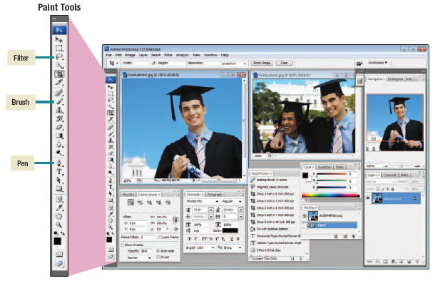

**Figure 4.1: Adobe Photoshop**

**4.1.3 Illustration Programs**

**Illustration programs,** also known as **drawing programs,** are used to create andedit vector images. **Vector** is another common type of graphic file. While bitmap images use pixels to represent images, **vector images,** also known as **vector illustrations,** use geometric shapes or objects. These objects are created by connecting lines and curves. Because these objects can be defined by mathematical equations, they can be rapidly and easily resized, colored, textured, and manipulated. An image is a combination of several objects.

Popular illustration programs include:

* Adobe Illustrator
* CorelDRAW,
* Inkscape.

**4.1.4 Image Gallery**

**Image galleries** are libraries of electronic images. These images are used for a wide variety of applications from illustrating textbooks to providing visual interest to presentations. There are two basic types of electronic images in these galleries:

(1) **Stock photographs** —photographs on a variety of subject material from people to landscapes.

(2) **Clip art** —graphic illustrations representing a wide range of topics. Most applications provide access to a limited selection of free clip art.

There are numerous Web image galleries. Some of these sites offer free images and clip art while others charge a fee.

|  |  |
| --- | --- |
| **Organization** | **Site** |
| Classroom clipart  ClipArt.com  Graphics Factory  MS Office clip art  iStockphoto | www.classroomclipart.com  www.clipart.com  www.graphicsfactory.com  office.microsoft.com/clipart  istockphoto.com |

**Table 4.1: Selected Web image galleries**

**4.1.5 Graphic Suites**

Some companies have combined or bundled their separate graphics programs in groups called **graphics suites.** Two popular suites are:

* CorelDRAW Graphics Suite
* Adobe Creative Suite

CorelDRAW Graphics Suite includes five individual graphics programs plus a large library of clip art, media clips, and fonts.

**4.2 Audio and video**

Digital **video editing software** allows you to reorganize, add effects, and more to your digital video footage. Two commonly used video editing software programs are:

* Apple iMovie
* Windows Movie Maker

These programs are designed to allow you to assemble and edit new home videos and movies from raw digital video footage.

**Audio editing software** allows you to record and edit audio clips. You can add audio effects, like filters, to your tracks. For example, you can use this type of software to filter out pops or scratches in an old recording. You can even use this software to create your own MP3s. Some commonly used audio editing software programs are:

* Apple GarageBand
* Sony ACID

**4.3 Multimedia**

Multimediais the integration of all sorts of media into one presentation. For example, a multimedia presentation may include video, music, voice, graphics, and text.

Effective multimedia presentations incorporate user participation or interactivity. **Interactivity** allows the user to choose the information to view, to control the pace and flow of information, and to respond to items and receive feedback. When experiencing an interactive multimedia presentation, users customize the presentation to their needs. Users are able to select the language to be used and decide whether to include sound.

Multimedia need a powerful microcomputer: fast processor and a large hard drive, soundboard, speakers and a CD-ROM drive (1 minute of video with stereo sound required 25 MB of disk space).

**4.3.1 Links and Buttons**

An interactive multimedia presentation is typically organized as a series of related pages. Each page presents information and provides **links,** or connections, to related information. These links can be to video, sound, graphics, and text files, and to other pages and resources. By clicking special areas called **buttons** on a page, you can make appropriate links and navigate through a presentation to locate and discover information. Typically, there are several buttons on a page. You can select one, several, or none of them. You are in control. You direct the flow and content of the presentation.

**4.3.2 Multimedia authoring programs**

Multimedia authoring programsare special programs used to create multimedia presentations. They bring together all the video, audio, graphics, and text elements into an interactive framework. Widely used authoring programs include:

* Adobe Director
* Toolbook.

**4.4 Web Authoring**

There are over a billion Web sites on the Internet, and more are being added every day. Corporations use the Web to reach new customers and to promote their products. Individuals create their own personal sites, called **blogs.** Creating a site is called **Web authoring.** It begins with site design followed by creation of a document file that displays the Web site’s content.

**4.4.1 Web site design**

Corporations create Web sites to reach customers and individuals create blogs to stay in touch with friends and family.

A Web site is an interactive multimedia form of communication. Designing a Web site begins with determining the site’s overall content. The content is then broken down into a series of related pieces of information. The overall site design is commonly represented in a **graphical map.**

Notice that in the graphical map shown in figure 4.2, each block in the map represents a Web page. Lines joining the blocks represent links to related pages of information that make up the Web site.

The first page, or home page, typically serves as an introduction and supplies a table of contents. The following pages present the specific pieces or blocks of information. Multimedia content like animation are added.

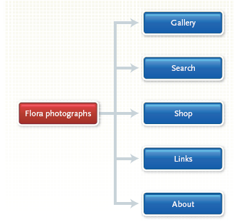

**Figure 4.2: Partial graphical map for the Flora Photographs Web site**

**4.4.2 Web authoring programs**

Web pages are typically HTML documents. With knowledge of HTML and a simple text editor, you can create Web pages. Even without knowledge of HTML, you can create simple Web pages using a word processing package like Microsoft Word.

More specialized and powerful programs, called **Web authoring programs,** are typically used to create sophisticatedcommercial sites. Also known as **Web page editors** and **HTML editors,** these programs provide support for Web site design andHTML coding. Some Web authoring programs are **WYSIWYG** (**what you see is what you get**) **editors,** which means you can build a page without interactingdirectly with HTML code. WYSIWYG editors preview the page describedby HTML code. Widely used Web authoring programs include:

* Adobe Dreamweaver
* NetObjects Fusion
* Microsoft Expression.

**4.5 Cell phone apps**

**Cell phone applications** are add-on features to a cell phone that allow users to perform a variety of tasks not typically associated with cell phone use. The traditional applications include address books, to-do lists, alarms, and message lists. With the introduction of smartphones and wireless connections to the Internet, cell phone capabilities have exploded. Now, a number of specialized applications are available.

**4.5.1 Apps**

Some of the most widely used cell phone apps are text messaging, Internet browsing, and connecting to social networks. Many apps are written for a particular type of cell phone and will not run on other types. For example, a cell phone app designed for Apple’s iPhone may not work with Google’s Android.

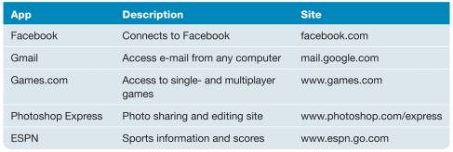

**Figure 4.3 Mobile apps**

**4.5.2 Apps store**

An app store is typically a Web site that provides access to specific cell phone apps that can be downloaded either for a nominal fee or free of charge. Two of the best-known stores are Apple’s App Store and Android Market.

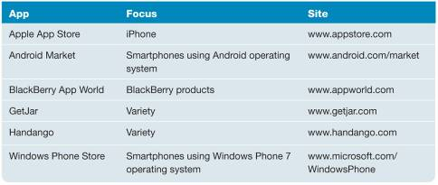

**Figure 4.4 Apps stores**